VySkan
Product Name | 4G LTE Advanced Vehicle Tracking Terminal
Product Model | VF95
Empowering fleet management with ultimate expandability, unwavering connectivity, and intelligent power control.

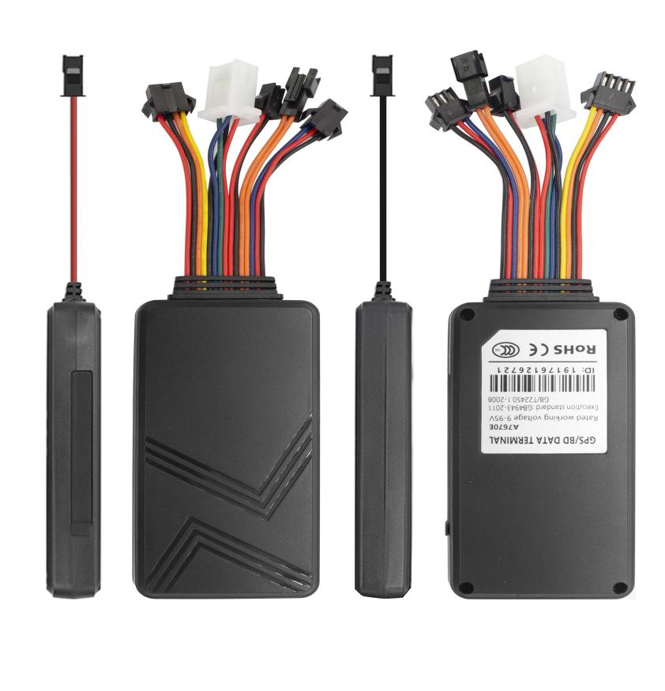
Engineered for the most demanding IoT and fleet applications, the VF95 is a highly integrated 4G LTE telematics terminal. Built with GPS/BDS dual-satellite positioning and a versatile suite of I/O interfaces, it delivers real-time asset visibility and seamless peripheral integration for any vehicle—from rental cars and electric scooters to heavy-duty logistics trucks.
1.Core Value
- Seamless Global Coverage & Precision
Powered by robust 4G LTE with 2G fallback , paired with a high-sensitivity GPS/BDS module. Experience pinpoint accuracy (<10m) and lightning-fast positioning, ensuring your assets are always on the map, no matter where they go.
- Ultimate I/O Expandability (Your Solution, Your Way)
Go beyond simple tracking. Equipped with RS232/RS485/TTL and 1-Wire interfaces , the VF95 easily integrates with external cameras, RFID readers, ultrasonic fuel sensors, and temperature probes. Build a customized IoT solution without changing the core hardware.
- Zero Data Loss Guarantee
Network blind spots? No problem. The built-in large-capacity flash memory automatically stores telemetry data during signal drops and seamlessly uploads it once the connection is restored. Every route, every alert, 100% secured.

- Intelligent Power & Active Defense
Features a 9V-90V wide operating voltage, making it compatible with almost any vehicle battery. Its smart sleep/wake mechanism drastically reduces power consumption. Coupled with multi-alert systems (vibration, power-cut, engine immobilization, SOS), it offers 24/7 active defense for your fleet.
2.Target Applications
- Logistics & Fleet Management
- Car Rental & Leasing Security
- Bikes & New Energy Vehicles
- High-Value Asset Tracking
3.Technical Specifications
3.1 Cellular & GNSS
Category | Specification | Description
Cellular Module | SIMCOM A7670E | Industrial-grade 4G LTE module.
Network Bands | 4G LTE-FDD: B1/B3/B5/B7/B8/B20  2G GSM: B3/B8  (Optional) | Broad coverage for global fleet operations.
SIM Card | Standard SIM | Push-push SIM card slot.
GNSS Module | AT6558D (GPS + BDS) | High-sensitivity dual-satellite tracking.
Positioning Accuracy | < 10 meters | Pinpoint accuracy for real-time tracking.
Start Time | Cold Start: 32s (Avg.)  Hot Start: 1s (Avg.) | Rapid acquisition supported by AGPS.
Antenna | Internal FPC Antenna | High-integration design.

3.2 Power & Electrical
Category | Specification | Description
Operating Voltage | DC 9V - 90V | Wide voltage range compatible with most vehicles.
Working Current | 65 mA @ 12V | Standard active tracking mode.
Sleep Current | 15 mA @ 12V | Intelligent low power consumption mode.
Backup Battery | 180 mAh / 3.7V Li-Polymer | Optional. Triggers power-cut alarms.

3.3 Interfaces & Expandability
Category | Specification | Description
ACC Detection | 1 Input | For ignition status detection.
Engine Cut-off | 1 Relay Output | Remote fuel/power cut-off via external relay.
1-Wire Interface | 1 Channel | Supports temperature sensors and iButton integration.
Serial Ports | RS232 / RS485 / TTL | Selectable (Default TTL). Integrates with Cameras, RFID, and Ultrasonic Fuel Sensors.
Audio & SOS | 1 Mic / 1 SOS Button | Optional. Enables emergency calls and voice monitoring.

3.4 Physical & Environmental
Category | Specification
Dimensions (L*W*H) | 99mm × 54mm × 16.5mm
Weight | 81g
Casing Material | Industrial ABS Plastic
Operating Temp. | -20℃ to +75℃
Operating Humidity | 10% - 85% RH (Non-condensing)
Sensors | Built-in 3-axis accelerometer (for vibration/tow alarms)

- Built for Rapid Integration
We know hardware is only half the solution. The VF95 is designed to drastically reduce your Time-to-Market (TTM) and development costs.
- Standard Protocols:
Natively supports TCP/UDP, GT06, and MQTT.
- Supported Platforms:
Seamlessly integrates with industry-leading tracking software including Wialon, Traccar, Gurtam, and Navixy without reverse engineering.
- Developer Tools:
Comprehensive Open API documentation and parsing scripts available for your IT team to achieve live dashboard connectivity in under 48 hours.

- A personalized plan prepared for you
- 1× VF95 Sample Device (Pre-configured)
- Full API & Protocol Documentation
- 1-on-1 Technical Support from our Field Engineers
Website：https://vyskan.com/
Email: marketing@vyskan.com

